Attic Infiltration Rate
For convenience, attic infiltration was originally specified as a fixed fraction of the living space infiltration. Since buildings of different performance (HERS Score) have different rates of air leakage, this led to a corresponding change in attic conditions. This does not reflect actual construction practice, as no effort is made to reduce air movement through the attic when sealing the conditioned space.

Therefore, the model was revised to assume the same rate of air leakage for all HERS levels. The infiltration rate increases in response to increased wind or driving temperature difference. In the absence of a better model, the AIM-2 infiltration model for single-story buildings is used, though intended primarily for living space, not attics. The suitability of this model was discussed in Montreal, however, the details are not expected to make much difference to the overall moisture behavior of the building. The leakage area is fixed at 567 sq in, chosen to give an air changes per hour times that of the living space for the HERS 100 house.

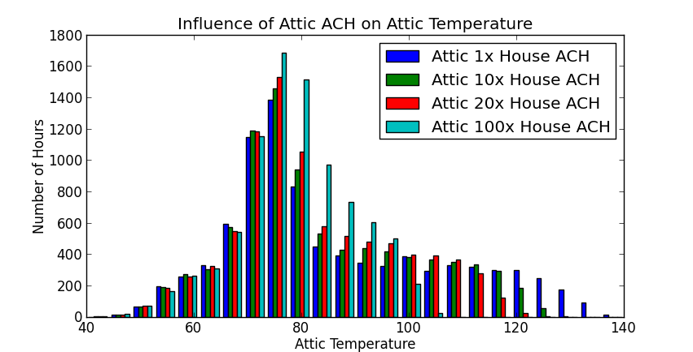 | 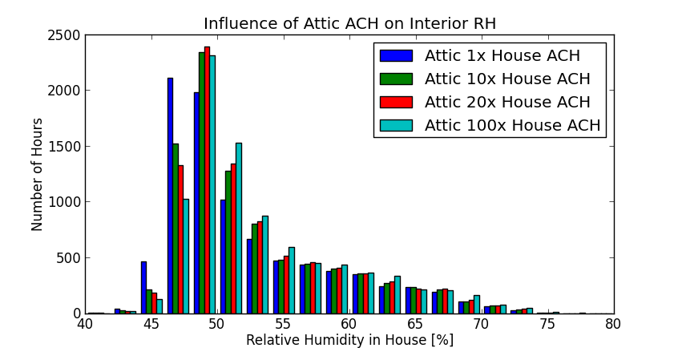

High-RH Trend with Decreasing HERS / Infiltration
A primary motivation for this research was the increase in latent load fraction in energy-efficient houses. As the Task 1 report explains:
Energy‐efficient houses in warm, humid climates have low sensible heat gain. Low sensible heat gain is good for reducing cooling costs, but contributes to part load moisture control challenges (Rudd et al. 2003, Rudd et al. 2005). Especially during Spring and Fall seasons, as well as rainy periods and summer nights, there are a significant number of hours where little or no sensible cooling is needed but moisture removal is still needed due to internal moisture generation and outside air exchange.
Observation of this effect is complicated by a trend to lower wintertime RH in more energy-efficient houses. The increased enclosure efficiency, combined with internal gains, leads to cooling runtime in winter in hot climates. This cooling runtime in turn reduces absolute humidity. The number of winter cooling hours is fairly small, even for HERS 50 houses, but substantially affects hours above 60% RH, which occur during the (predominately) non-cooling season.
For this modeling, it is assumed that the cooling setpoint is uniform throughout the year, and that the air conditioning will run to maintain setpoint even in winter. This can be seen as a conservative assumption, since it leads to some baseline dehumidification in the high-efficiency houses. It is unknown how many residents of high-efficiency houses actually operate their homes this way, and how many allow interior temperatures to rise higher in winter time. For the purposes of analysis, high humidity hours are reported at two thresholds, 50% and 60%, and on a monthly basis, which reveals both the increased winter cooling and decreased summer cooling in the high-efficiency houses.
These setpoint changes were discussed at the meeting for TC 6.3 in Montreal.
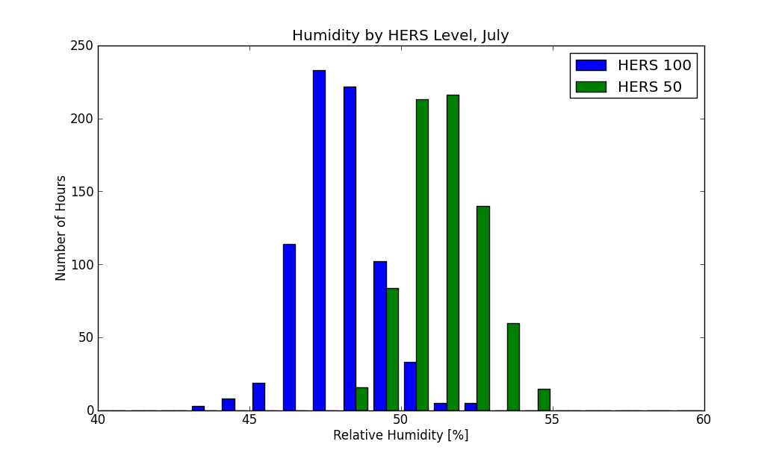 | 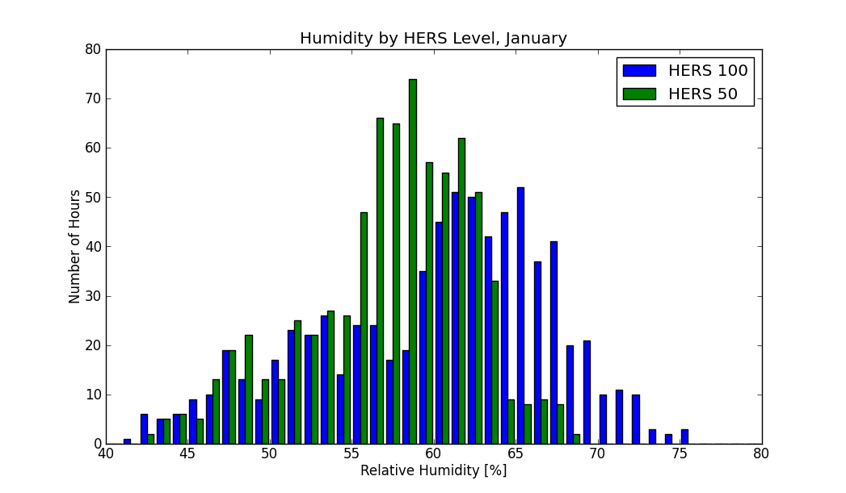

72F Setpoint in Hot Climates, 70F Elsewhere
Heating setpoints in all climates were adjusted from the values proposed in the Task 4 Plan in order to bring simulation results into closer agreement with field measurements. The new setpoints are 70F in zones 3, 4, and 5, and 72F in zones 1 and 2. The higher heating setpoint in southern climates is justified both by model sensitivity studies and by the expectation that occupants acclimated to warmer weather will keep their houses correspondingly warmer in winter.

Increasing indoor temperature reduces relative humidity by increasing the moisture capacity of the air. This is the main mechanism by which increased heating setpoint reduces hours of high relative humidity. As discussed above, most periods with RH > 60% occur during the heating season, because cooling removes water. The increased heating setpoint is therefore associated with somewhat higher relative humidity in summer, and reduced humidity in winter.
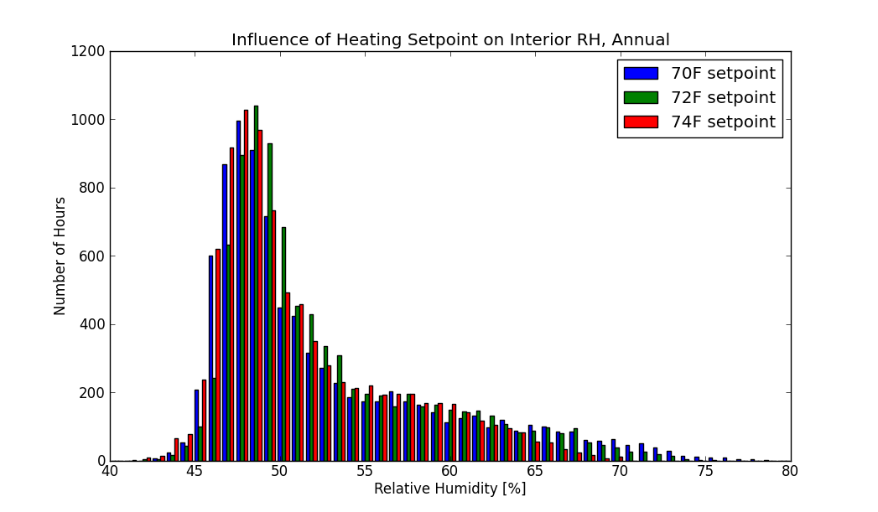 | 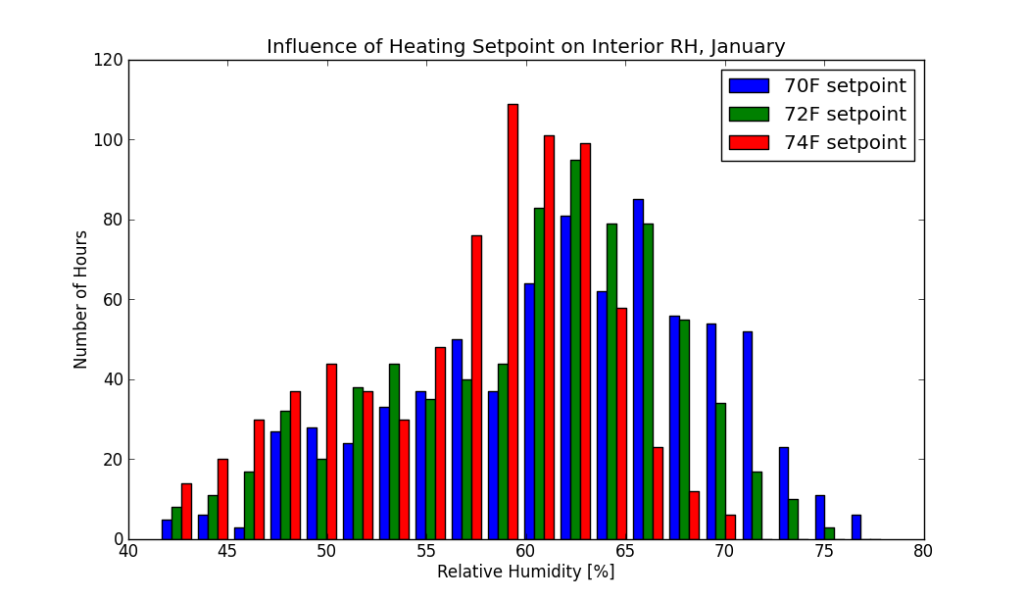

Dehumidifier Sizing for System 7 (Ducted Dehumidifier with Outdoor Air Preconditioning)
The dehumidifier for system 7 (Ducted Dehumidifier with Outdoor Air Preconditioning) has been changed from 65 pints/day (Task 4 Plan) to 90 pints/day. When used in the system 7 configuration, the smaller dehumidifier cannot provide the 62.2 ventilation rate. The larger dehumidifier has an airflow of 220 CFM. With 1/3 of the airflow from outside, and 2/3 from inside for tempering, the outdoor airflow rate is 73 CFM. The 62.2 rate is 58 CFM, so long DH runtimes would result in excess ventilation. When the dehumidifier has run long enough to provide an average of 58 CFM in the last hour, the outside air duct is closed, and the dehumidifier draws the entire 220 CFM from the interior.

Minor Changes
Dehumidification mode airflow for system 10 was changed to match system 2. System 10 is a sensitivity study, modeling the reduced-airflow component of system 2, without overcooling. System 2 calls for 200 CFM/ton through the air-conditioner while in dehumidification mode. Previous documentation stated that System 10 would run at 250 CFM/ton.
System 5 (stand-alone dehumiidfier) runs will include all ventilation systems. Previous documentation stated that scenarios with HRV or ERV would be omitted.

